**Html project**

**Name /** **Eslam Ehab Abdelmonem Ahmed**

**Section / 8**

**B.N / 179**

**Gethub-link /** [eslamehab7/html.project.repository (github.com)](https://github.com/eslamehab7/html.project.repository)

**Gethub-page (published)**/ <https://eslamehab7.github.io/html.project.repository/>

**____________________________________________________**

Topic / **Artificial intelligence (AI)**

Brief / **Artificial intelligence (AI) refers to the simulation of human intelligence in machines that are programmed to think like humans and mimic their actions. The term may also be applied to any machine that exhibits traits associated with a human mind such as learning and problem-solving. The ideal characteristic of artificial intelligence is its ability to rationalize and take actions that have the best chance of achieving a specific goal . choosing al because AI is important because, for the first time, traditionally human capabilities can be undertaken in software inexpensively and** **at scale. AI can be applied to every sector to enable new possibilities and efficiencies.**

Screenshots **/ page1**

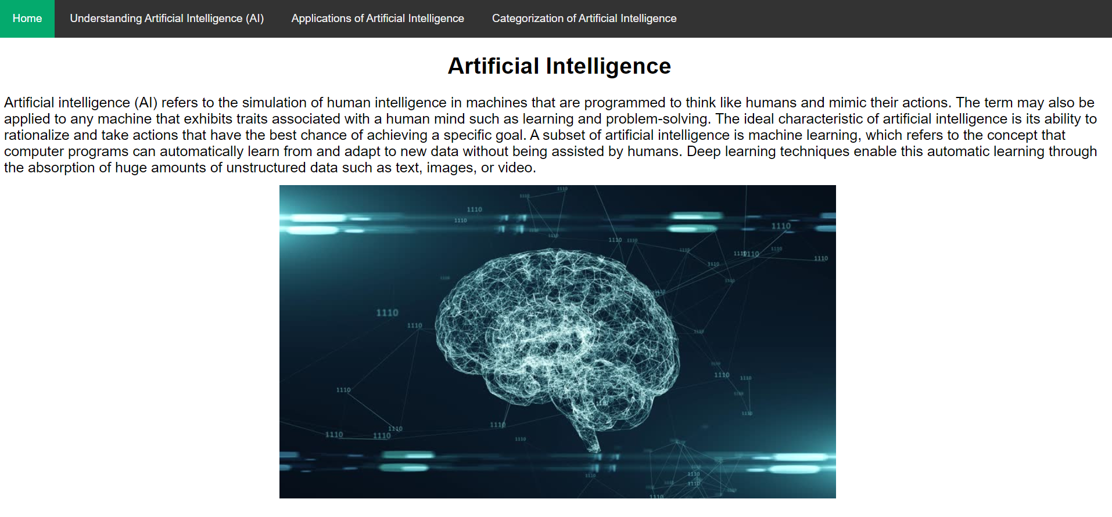

**Page 2**

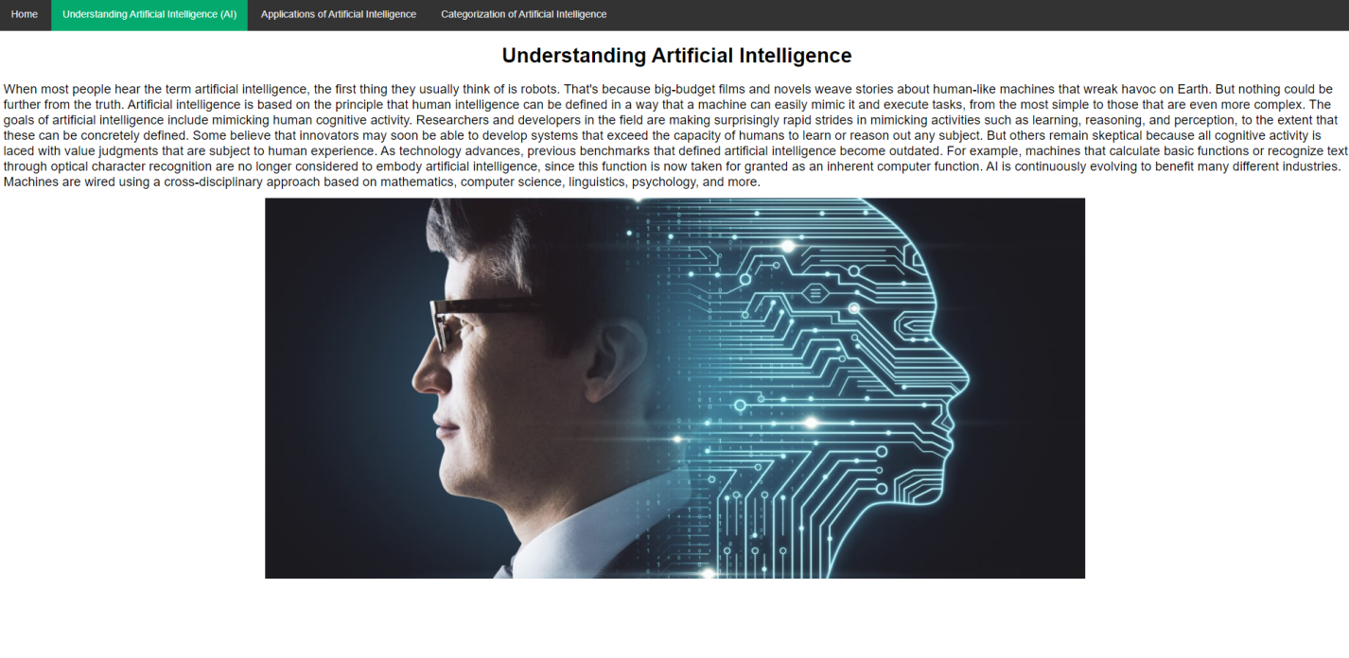

**Page 3**

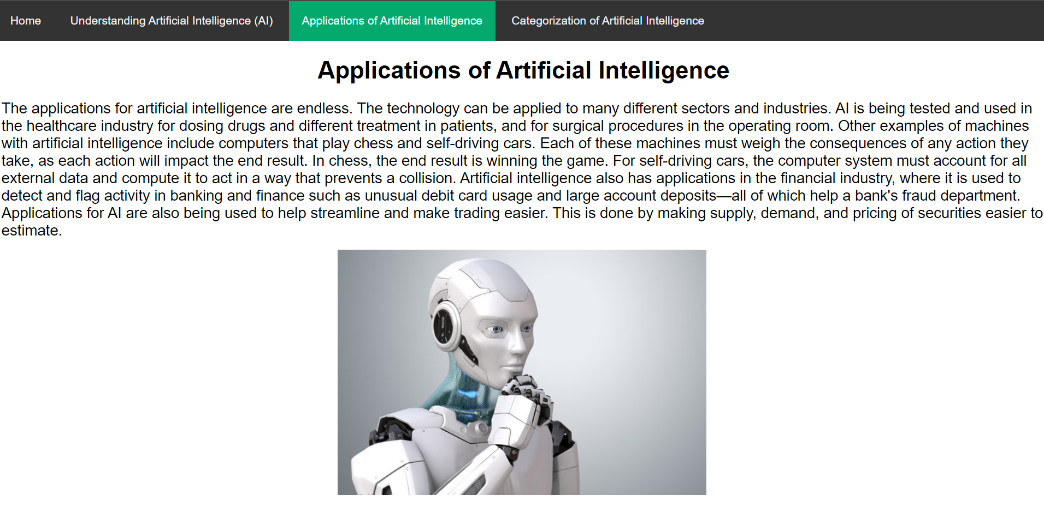

**Page 4**

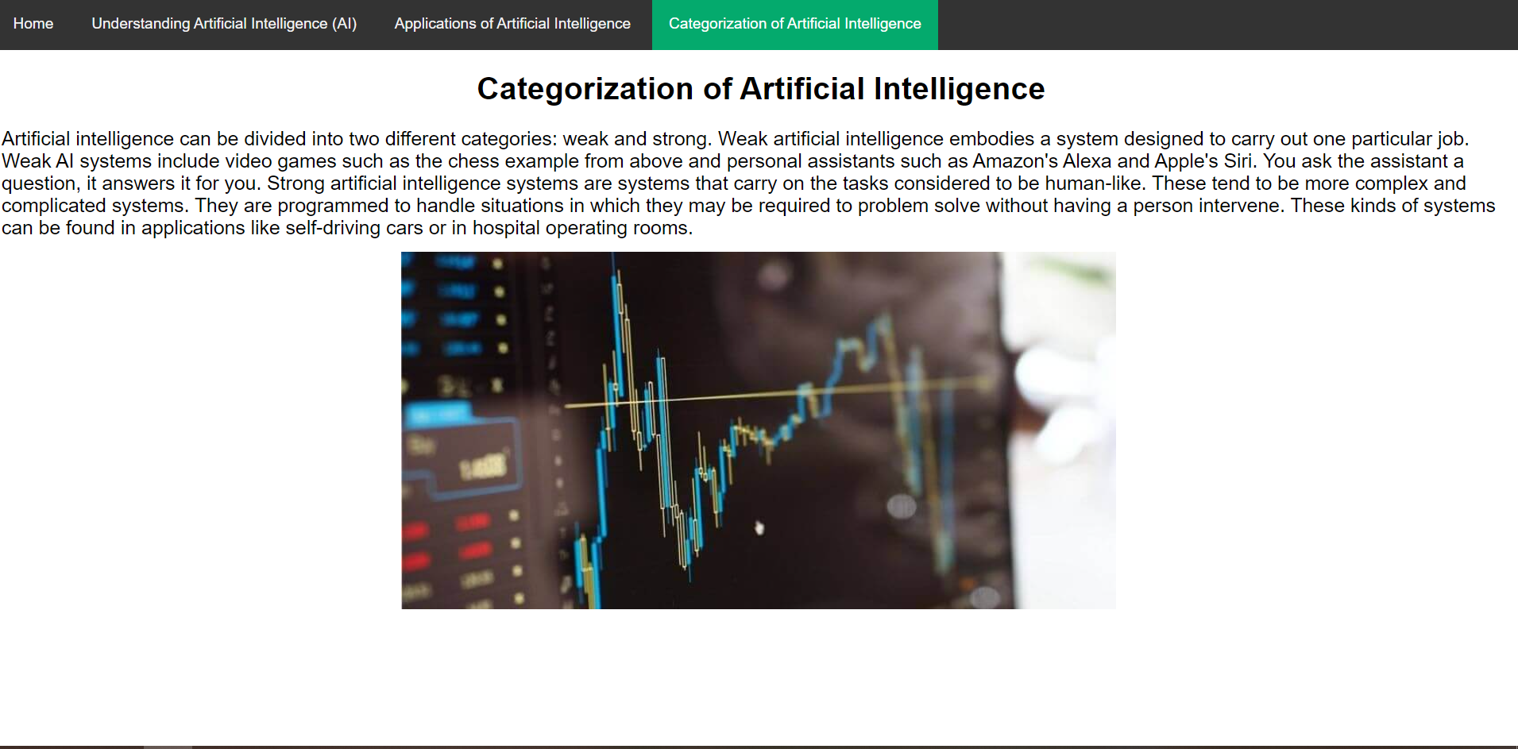

## Source code /

